
SRM Institute of Science and Technology
Mode of Exam
OFFLINE
College of Engineering and Technology
School of Computing
DEPARTMENT OF COMPUTING TECHNOLOGIES
SRM Nagar, Kattankulathur – 603203, Chengalpattu District, Tamilnadu
Academic Year: 2023-2024 (ODD) Batch 2 – SET A
Test: CLAT-3 Date: 9/11/2023 Course Code & Title:18CSE458T/Wireless and Mobile Communication Duration: 1Hr 40 Mins
Year & Sem: VII Max. Marks: 50

Course Articulation Matrix:
CO/PO | PO1 | PO2 | PO3 | PO4 | PO5 | PO6 | PO7 | PO8 | PO9 | PO10 | PO11 | PO12 | PSO1 | PSO2 | PSO3
CO1 | 3 | 2 | - | - | - | - | - | - | - | - | - | - | - | - | -
CO2 | 2 | - | - | - | - | - | - | - | - | - | - | - | - | - | -
CO3 | 2 | - | - | - | - | - | - | - | - | - | - | - | - | - | 2
CO4 | 3 | - | 1 | - | - | - | - | - | - | - | - | - | - | - | -
CO5 | 3 | 1 | 2 | - | - | - | - | - | - | - | - | - | - | - | -

Part – A
(10 x 1 = 10 Marks)
Instructions: Answer all
Q. No | Question | Marks | BL | CO | PO | PI Code
1 | In practical IPv6 application, a technology encapsulates IPv6 packets inside IPv4 packets, this technology is called  a. Tunneling  b. Hashing  c. Routing  d. NAT | 1 | 1 | 4 | 1 | 1.6.1
2 | IP assigned for a client by DHCP server is  a. for a limited period  b. for unlimited period  c. not time dependent  d. none of these | 1 | 1 | 4 | 1 | 1.6.1
3 | In TCP protocol to mitigate congestion, TCP —————–the transmission rate dramatically.  a. Stop the transmission  b. Wait to resolve the congestion  c. Slows down  d. None of the above | 1 | 1 | 4 | 1 | 1.6.1
4 | M-TCP is specially adapted to the problems arising from lengthy or frequent ————–  a. Delay packet  b. Packet loss  c. disconnections  d. None | 1 | 1 | 4 | 1 | 1.6.1
5 | The gateway of WAP translates the request using _____?  a. Micro browser  b. Marco browser  c. Small browse  d. None of the above | 1 | 1 | 4 | 1 | 1.6.1
6 | In IEEE 802.11, distributed coordination function(DCF) uses__________as the access method.  a. CSMA/CA  b. CSMA/CD  c. ALOHA  d. None of the choices are correct. | 1 | 1 | 5 | 1 | 1.6.1
7 | The Single Piconet formed by  a. One Slave and One Master  b. One Slave and Multiple Masters  c. Multiple Slaves and One Master  d. Multiple Slaves and Multiple Masters | 1 | 1 | 5 | 1 | 1.6.1
8 | What is the routing algorithm used in MANETs?  a. Shortest Path First  b. Distance Vector Protocol  c. Ad-hoc On-demand Distance Vector Protocol  d. Routing Information Protocol | 1 | 1 | 5 | 1 | 1.6.1
9 | What type of routing is used in VANET?  a. Single layer routing  b. Cross Layer Routing  c. Hybrid Routing  d. AP Routing | 1 | 1 | 5 | 1 | 1.6.1
10 | Which of the following technology is mainly designed for indoor coverage?  a. Femtocell network  b. 3GPP  c. LTE  d. AMPS | 1 | 1 | 5 | 1 | 1.6.1
Part B
(4 X 5 = 20 Marks)
11 | Define Tunneling. Explain Forward Tunneling and Reverse Tunneling. | 2 | 1 | 4 | 1 | 1.6.1
12 | Discuss about the key principles and functions of the Wireless Datagram Protocol (WDP)?" | 2 | 2 | 4 | 1 | 1.6.1
13 | Summarize the phases of HIPERLAN. | 2 | 2 | 5 | 1 | 1.6.1
14 | Describe Push to talk technology for SMS. | 2 | 2 | 5 | 1 | 1.6.1
Part – C
( 2 x 10 =20 Marks)
Instructions: Answer any one
15 a.  b. | Discuss in detail about Classical TCP improvements.  (or)  What is the purpose of WML and how does WML Script enhance its functionality in the context of mobile web development? | 10 | 2 | 4 | 1 | 1.6.1
16 a.  b. | Describe in detail about IEEE802.11 System Architecture and Protocol Architecture.  (or)  Explain in detail about DSR Routing Protocol. | 10 | 2 | 5 | 1 | 1.6.1

Course Outcome (CO) and Bloom’s level (BL) Coverage in Questions
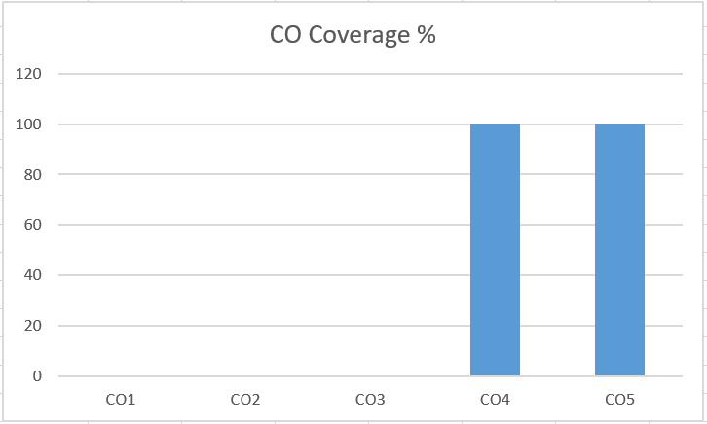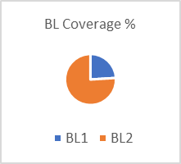

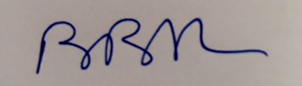

Approved by the Audit Professor/Course Coordinator

